You are given an m x n integer array grid. There is a robot initially located at the **top-left corner** (i.e., grid[0][0]). The robot tries to move to the **bottom-right corner** (i.e., grid[m - 1][n - 1]). The robot can only move either down or right at any point in time.

An obstacle and space are marked as 1 or 0 respectively in grid. A path that the robot takes cannot include **any** square that is an obstacle.

Return *the number of possible unique paths that the robot can take to reach the bottom-right corner*.

The testcases are generated so that the answer will be less than or equal to 2 * 109.

**Example 1:**

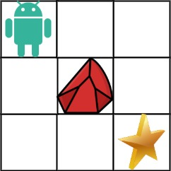

Input: obstacleGrid = [[0,0,0],[0,1,0],[0,0,0]]  
Output: 2  
Explanation: There is one obstacle in the middle of the 3x3 grid above.  
There are two ways to reach the bottom-right corner:  
1. Right -> Right -> Down -> Down  
2. Down -> Down -> Right -> Right

**Example 2:**



Input: obstacleGrid = [[0,1],[0,0]]  
Output: 1

**Constraints:**

* m == obstacleGrid.length
* n == obstacleGrid[i].length
* 1 <= m, n <= 100
* obstacleGrid[i][j] is 0 or 1.